MUHAMMAD DANIAL AKMAL BIN ROSLI (273046)

1.

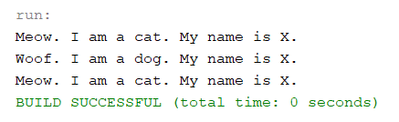

2. Polymorphism is a concept in which we can create a coding with many objects inherited.

3. When classes Dog and Cat are called in the main class Lab1Stage1, it will inherit the characteristics of both classes.

4. The class Animal is not called in the main class.

5. The result is the same as in Question 1 above.

6. In Cat and Dog classes.

7. The code detects Cat and Dog classes that are called corresponding to the array allAnimals. While the variable i is less than the length of the array, the array displays the method introduceYourself of both Cat and Dog.

8. While the variable i is less than the length of array allAnimals, the array displays the method introduceYourself of both Cat and Dog accordingly. After that, i increases by 1 until i reaches the value of the length of array allAnimals.

9.

